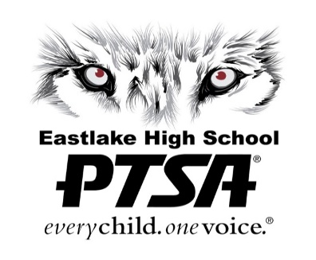 | EHS PTSA  400 228th Ave NE  Sammamish, WA 98074  www.ehsptsa.org

Dear Local Business Manager/Owner:

As a local business, you know the importance of efficient and effective marketing as well as showing your commitment to the community. The Eastlake High School (EHS) Parent Teacher Student Association (PTSA) has a solution to help you achieve both: Become an EHS PTSA Community Partner. This partnership supports our school, which consists of more than 2,000 students and 200 staff members (as well as their families), and it promotes your business through the EHS PTSA.

The EHS PTSA is an all-volunteer, non-profit organization working to support Eastlake High School. It is the only organization at EHS that supports all students and actively works to link the school with the community. The mission of the EHS PTSA is to:

Inspire unity. Exceed standards. Achieve success for all students.

As an EHS PTSA Community Partner

You and your business will receive for the 2023-2024 school year:
- a certificate acknowledging your community support and partnership with the EHS PTSA, to display in your window or office.
- continual support from the EHS PTSA in promoting your business through its weekly e-newsletter, website, and social media (Facebook), utilizing your logo, contact info, link to website, and/or other standard means.

We greatly appreciate and thank you in advance for your consideration and support.

Questions should be directed to waysandmeans@ehsptsa.org.

Sincerely,
Brittin Dwyer
VP Ways & Means, EHS PTSA 2023-2024
YES! I/We would like to be a 2023-2024 EHS PTSA Community Partner!
Please return completed form to:

Eastlake High School PTSA
Brittin Dwyer, VP Ways & Means
400 228th Avenue NE
Sammamish, WA 98074

Name of Business: _____________________________________________________________________
Type of Business (if not indicated in title): __________________________________________________
Contact Name: ________________________________________________________________________
Address: _____________________________________________________________________________
City, State, Zip: ________________________________________________________________________
Contact Email: _________________________________________________________________________
Contact Phone Number: _________________________________________________________________
Website: _____________________________________________________________________________
Will you be providing a digital file of your logo for the EHS PTSA to use? Yes No
Enclosed please find my donation of: _____________________________________________________

- EHS PTSA agrees to promote the partner through its Wolf Tracks newsletter, website, and Facebook page throughout the school year (September through June)
- By signing, you agree to be a community partner for the current school year, ending June 30. Renewal is required for continuation of partnership after the current school year.
Thank you for partnering with us!
The Eastlake High School PTSA

PTSA Elected Officer Signature: ____________________________________________________________
PTSA Co-President Signature: _____________________________________________________________

Eastlake High School PTSA reserves the right to deny sponsorship requests that aren’t appropriate or do not align with our mission, value and goals of our PTSA. In addition, the EHS PTSA also reserves the right to terminate the contract at any time at the Boards discretion. Lake Washington School District does not sponsor, endorse, or recommend any of the organizations, services, or activities described in these materials. In consideration for the privilege to distribute these materials, LWSD shall be held harmless from any causes of action filed in any court or administrative tribunal arising out of the distribution of these materials, including all costs, attorney fees, judgments, or awards. Additional financial information for EHS PTSA on file with the Secretary of State at (800) 332-4483.

